Match the photo of the landmark with the country.

1. 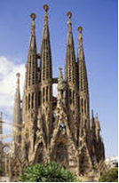 Gaudí’s Cathedral Of The Sacred Family
2. Spain
3. Romania
4. Italy
5. Poland

Answer: a

1. 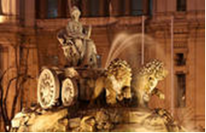 The Cibeles Fountain, Madrid
2. Italy
3. Bulgaria
4. Spain
5. Romania

Answer: c

1. 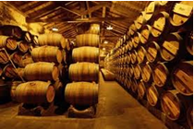 Wine Barrels From The Rioja Region
2. Spain
3. Italy
4. Romania
5. Turkey

Answer: a

1. 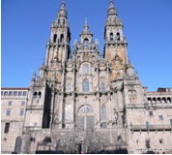 The Cathedral Of Santiago De Compostela, A Coruña
2. Italy
3. Spain
4. Poland
5. Bulgaria

Answer: b

1. 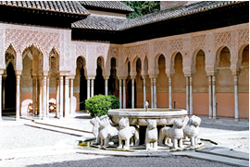 The Alhambra Of Granada
2. Romania
3. Spain
4. Italy
5. Poland

Answer: b